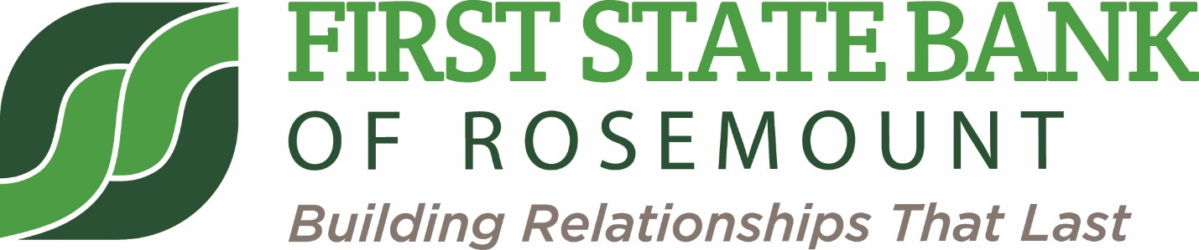

Community Giving Request Form

Name:
Email Address:
Phone:

Name of Organization:
Is Your Organization an Established Nonprofit? Yes No
Has the First State Bank of Rosemount Previously Contributed to Your Organization?
Yes No

Purpose of the Contribution:
Amount of Donation Request:

Please Complete this Form and Return to the First State Bank of Rosemount or email to Missy Toombs at mjt@fsbrosemount.com.

